E-COMMERCE Sales Analysis for (2011-14)

Introduction
This repository contains data and analysis on E-Commerce Sales for the years 2011 to 2014. The data has been collected from official sources and is intended for research and informational purposes.

Problem Statement:
This project aims to conduct a detailed analysis of E-commerce sales data in the USA spanning from 2011 to 2014. The primary focus is on understanding sales and profit trends on a yearly basis, examining sales distribution across states, determining the top three categories contributing to sales share, analyzing category-wise profitability, and identifying the top five sub-categories based on sales volume.

Key Objectives:
- Yearly Sales and Profit Analysis: Analyze the sales and profit data for each year from 2011 to 2014 to identify trends, growth patterns, and profitability ratios. This analysis will provide insights into the overall performance of E-commerce sales in the USA over the four-year period.

- Sales Distribution by State: Investigate the geographical distribution of sales across different states in the USA. Understanding regional variations in sales can help in targeting specific areas for marketing efforts and optimizing logistics and distribution networks.

- Top Three Category Sales Share: Determine the top three categories contributing to the majority of sales revenue. This analysis will highlight the most lucrative product categories and guide strategic decision-making related to inventory management and marketing strategies.

- Category-Wise Profit Analysis: Evaluate the profitability of each product category to identify high-margin and low-margin product segments. Understanding category-wise profitability can aid in resource allocation, pricing strategies, and product assortment planning.
- Top Five Sub-categories by Sales Volume: Identify the top five sub-categories based on sales volume to gain insights into consumer preferences and purchasing behavior. This information can be used to prioritize product development efforts and tailor marketing campaigns to target specific product segments effectively.

By addressing these objectives, this analysis will provide valuable insights into the performance and dynamics of E-commerce sales in the USA, enabling businesses to make informed decisions and optimize their operations for improved sales and profitability.

Data Sources
- E-Commerce Sales Data for (2011-2014) for U.S.A has been sourced from Kaggle.

Step Followed
- Step 1 : Loading data into Microsoft Excel ,dataset is a csv file.
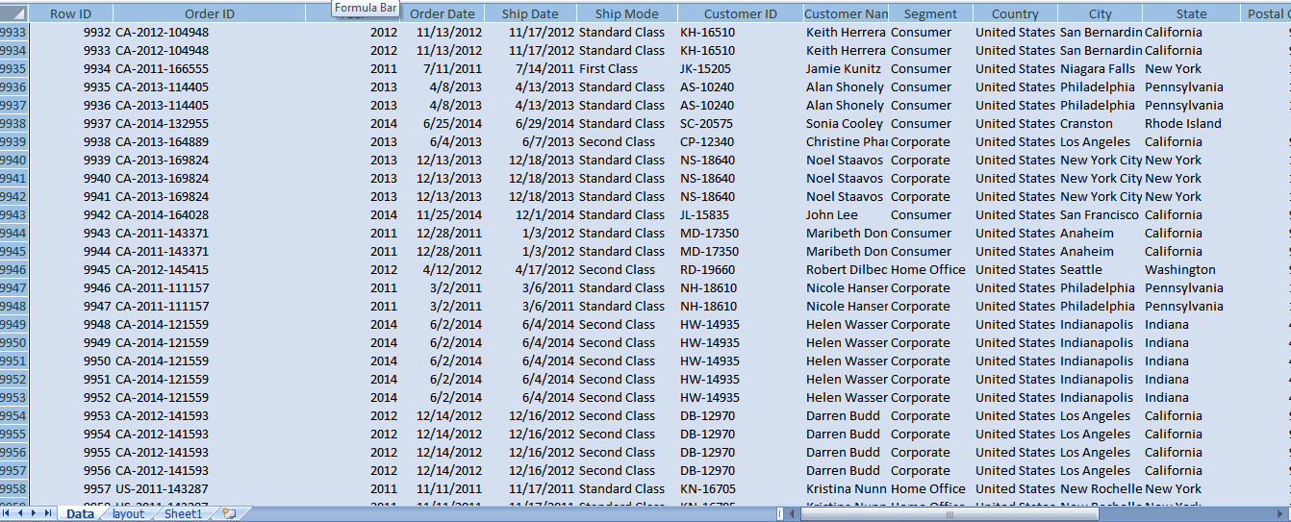

- Step 2 : After Data Collection now Preprocessing it to Ensure data integrity, handling missing values, and perform any necessary data cleaning tasks.

- Step 3 : For yearly sales and profit analysis we calculate total sales and profits for each year (2011-2014).

- Step 4 : We visualize trends over time using Stacked line with column charts to identify patterns or anomalies.

- Step 5 : For getting aggregate sales data by state we make Sales Distribution by State where we illustrate sales distribution across different states in the USA.

- Step 6 : For visualizing the sales distribution by state we used column chart.

- Step 7 : For top three Category Sales Share we Summarize sales data by product category , then Identify the top three categories with the highest sales revenue.

- Step 8 : We also calculated the sales share of each category over the entire period of 2011 to 2014.

- Step 9 : For visualizing the Category Sales Share we used Pie Chart.

- Step 10 : For Category-Wise Profit Analysis we calculated profits for each product category then determine the profitability ratio (profit/sales) for each category.

- Step 11 : To visualize the profitability of different categories we use bar charts.

- Step 12 : To find the Top Five Sub-categories by Sales Volume we firstly aggregate sales data by sub-category, then rank sub-categories based on sales volume.

- Step 13 : Then we identify the top five sub-categories with the highest sales and visualize them using Pie Chart.

Dashboard After Completion :

- After Completion Dash board looks like this .

